BizLink demonstrates elocab high end endoscopy cable solutions at Compamed 2023
Individual cable systems transmit pin-sharp images with hygienic and safe handling
Georgensgmuend, Germany, 08 November 2023 – Endoscopy cable systems with interference-free, pin-sharp images in groundbreaking quality for any camera concept up to 4K resolution is one of the core businesses from BizLink, a leading global interconnect solutions provider. BizLink’s elocab custom solutions for endoscopy have long service lives and minimize the risk of infection as they are resistant to cleaning and disinfection agents, oils, UV radiation, chemicals and much more. BizLink will show its latest developments for endoscopy at Compamed in Düsseldorf, Germany from November 13th to 16th at their booth 8BJ27.
BizLink’s elocab custom cables and systems for endoscopic applications are outstanding solutions and are preferred by the world’s leading endoscope manufacturers. “Each application has its own special requirements”, says Dr. Lukas von Arx, Managing Director and Vice President of Tailor-Made Products Business Unit at BizLink. “Our strength is to find the perfect solution for our customer’s needs. For example our very flexible tube solutions or diameter optimized hybrid cable solutions.”, he adds. All elocab endoscopic assemblies especially excel in their image transmission, hygienic properties and the very special Si-tec silicone surface. Si-tec is the most comfortable surface for such applications in the market and merges the great hygienic silicone surface characteristics with a superior anti slip stick behavior. The cable has maximum sealing and the optimized designs ensure clear and interference-free image transmission while the exceptional sheath material, which has proven itself in practice, provides ergonomic and secure handling.
“No matter which solution the customer chooses, we always offer the full range of options. For example, fiber bundles for illumination, overmolding for autoclavability or sterrad, various connector solutions, high speed copper pairs, coaxes and optical data fibers for video transmission and of course everything with biocompatibility and ISO 13485 compliance.”, comments Dr. Lukas von Arx. This also means ensuring document traceability and risk management. “We are familiar with the increasingly stringent requirements being imposed by the authorities, and are the perfect development partner for sustainable and durable products.” BizLink offers its customers an integrated range of products and services that extends from system engineering and cable manufacture through to complex cable systems with integrated mechanical and electronic components. This diversity of options and components enables perfect customization.

About BizLink
BizLink, founded in 1996, is headquartered in Silicon Valley, USA. Our mission is to make interconnection easier and to become a leading global interconnect solution supplier. We support environmentally-conscious industries and improve quality of life through providing essential components, wire harnesses, and cables to a wide variety of industries such as IT Infrastructure, Client Peripherals, Optical Fiber Communications, Telecom and Networking, Electrical Appliances, Healthcare, Factory Automation, Machinery and Sensors, Motor Vehicle, Rolling Stock, Marine, Industrial, and Solar. With flexible production resources and global R&D teams in America, Europe, and Asia, BizLink always provides reliable interconnect solutions in close proximity to markets. BizLink also specializes in offering one-stop EMS and NPI services based on customer's requests. At BizLink, we strive to keep collaborating closely with customers to turn their innovative ideas into reality.
Contact person
Mika Nachtrab
Junior Marketing Specialist
Tailor-Made Products Business Unit
BizLink elocab GmbH
Phone +49 9172 6980-531
E-Mail mika_nachtrab@bizlinktech.com

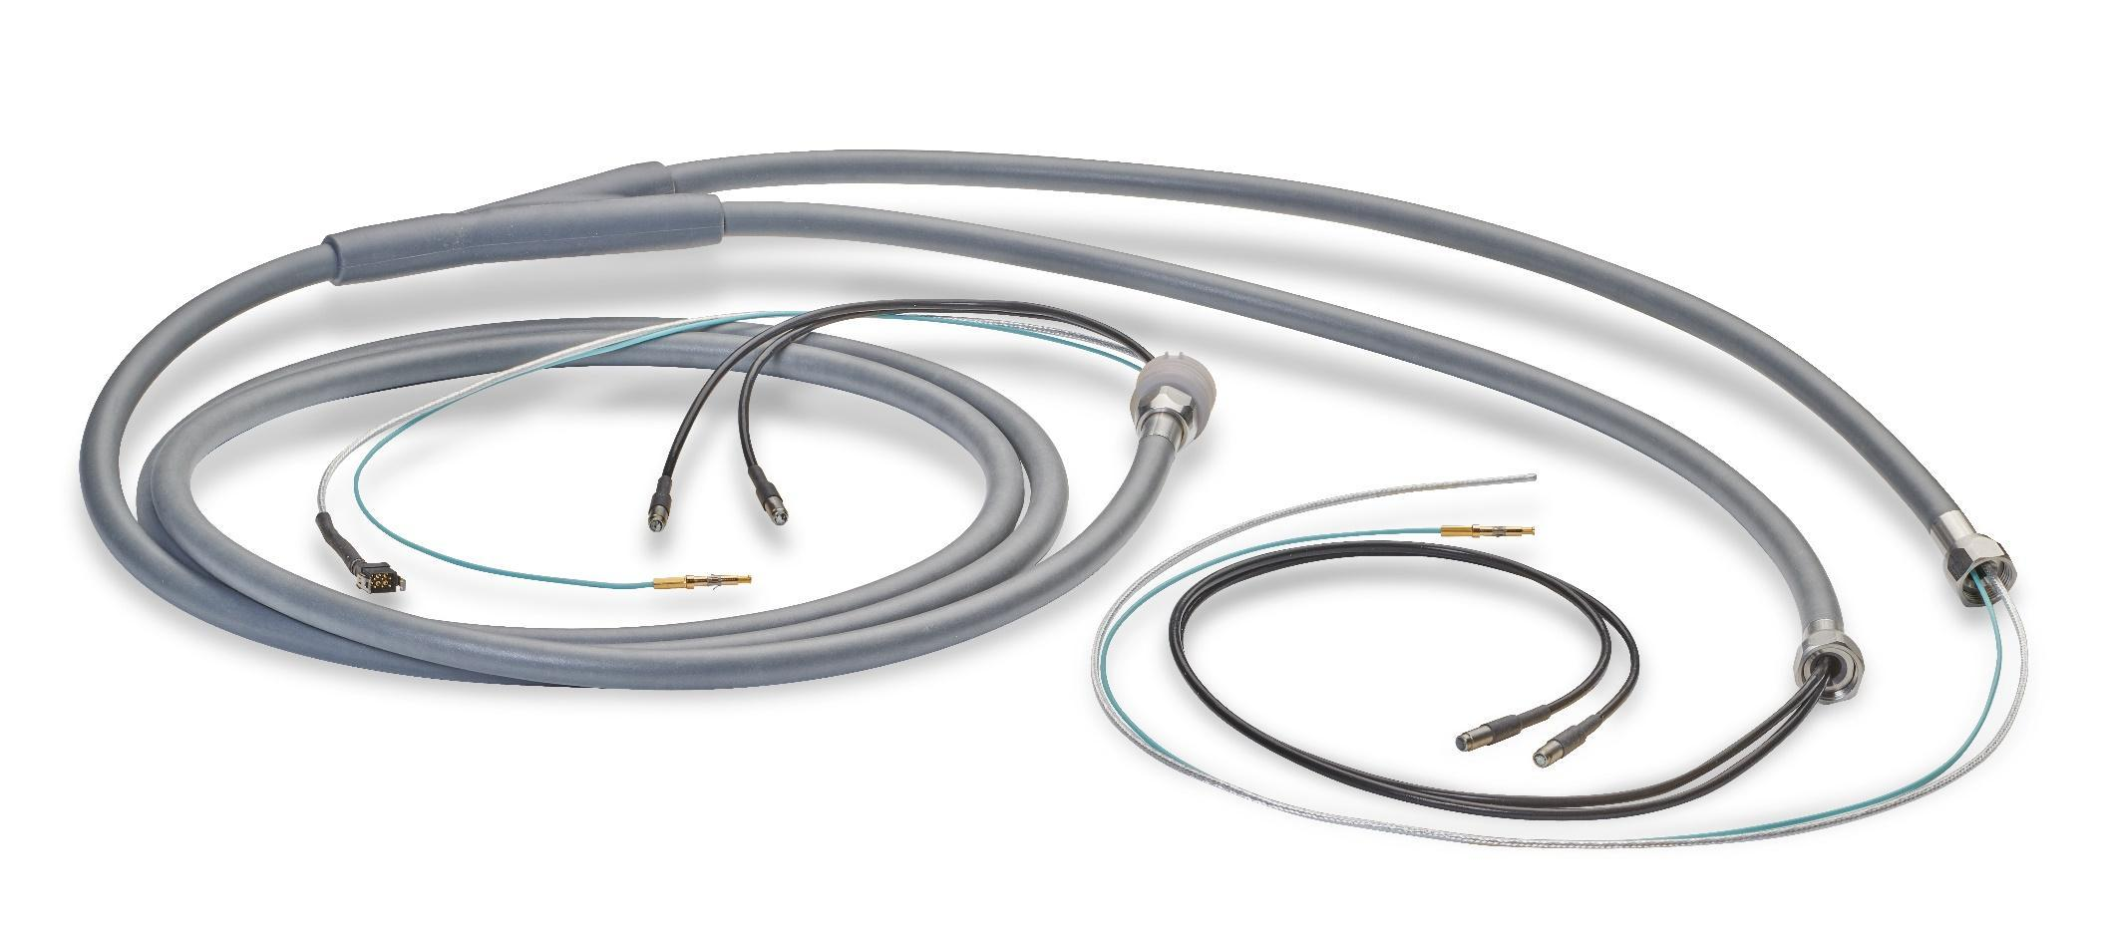
Caption: BizLink elocab endoscopy cable solutions combine high-resolution image transmission with hygienic and smooth handling.

